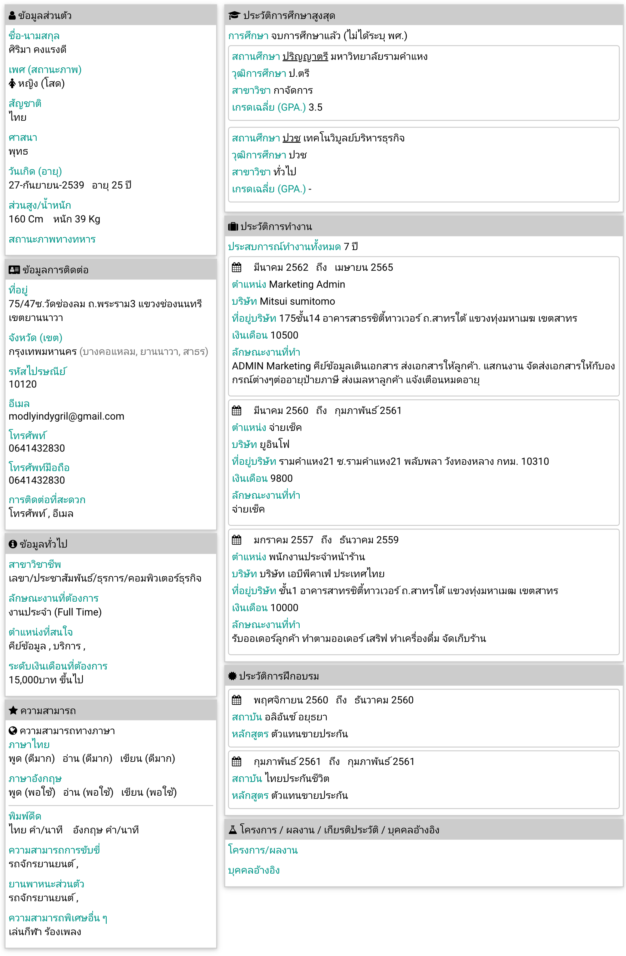

Http://www.JobTH.com/detailresume.php?gid=0003685589CCDQK